CareView Community Church 2014

3 0n 3 Basketball Tournament Registration Form
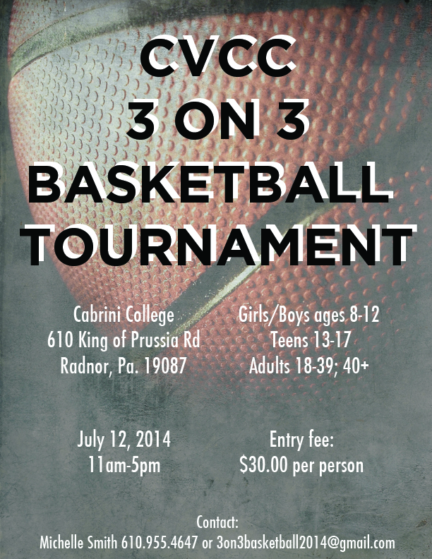
Team Registration:
Team Name_________________________________
Name | Captain? | Age | T- Shirt Size | Amt Paid?
 |  |  | S M L XL
 |  |  | S M L XL
 |  |  | S M L XL
 |  |  | S M L XL
 |  |  | S M L XL
Does anyone have any medical issues? If so please describe
_______________________________________________________________________________
Emergency Contact Name:___________________________Number________________________
Please send completed form to Michelle Smith @ 3on3basketball2014@gmail.com
Questions? Contact Michelle Smith 610-955-4647 or 3on3basketball2014@gmail.com
http://careviewcommunitychurch.org

